Assignment 3

Task: Create a virtual machine using the azure portal, install a web server and host a simple webpage

Task: Manage the created virtual machine, demonstrating how to start, stop and resize the vm.

· The simplest way to log in to Azure is to use the az login command.

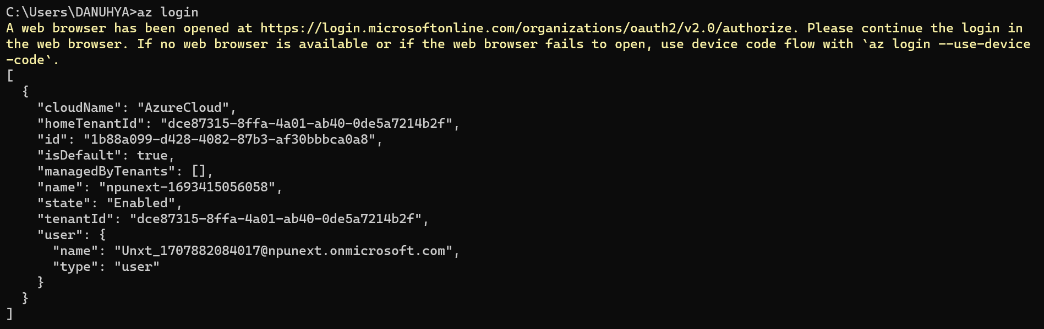

· Creating a resource group with location as southindia

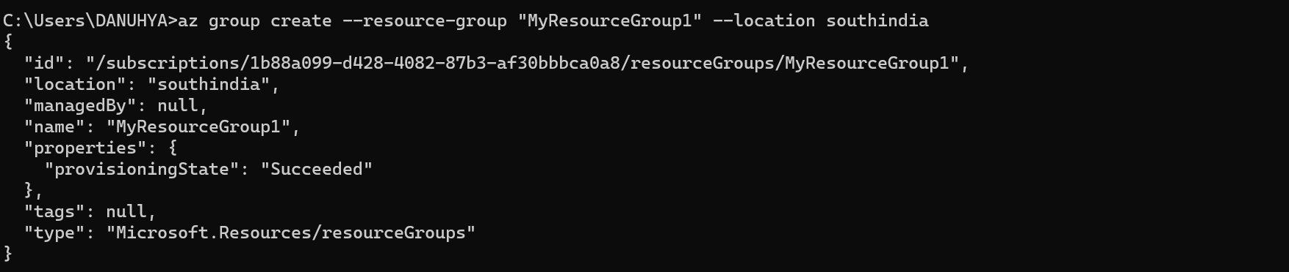

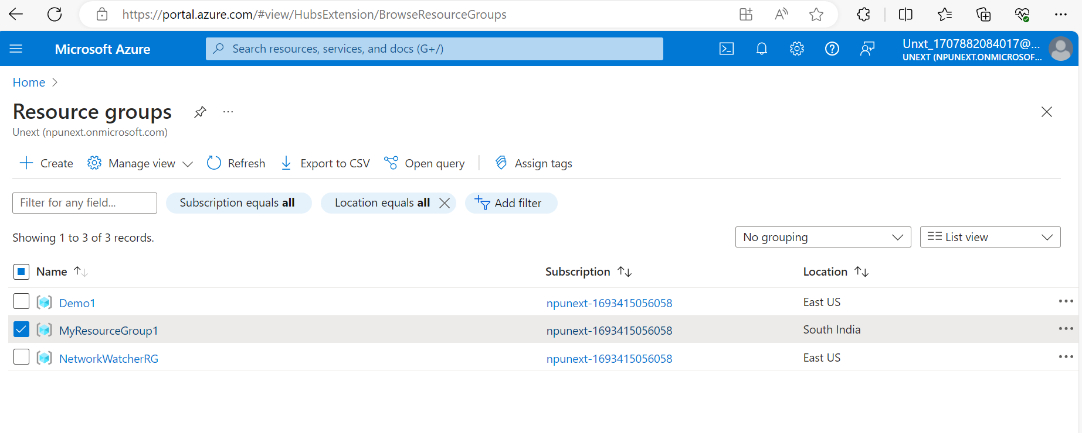

· Creating a virtual machine

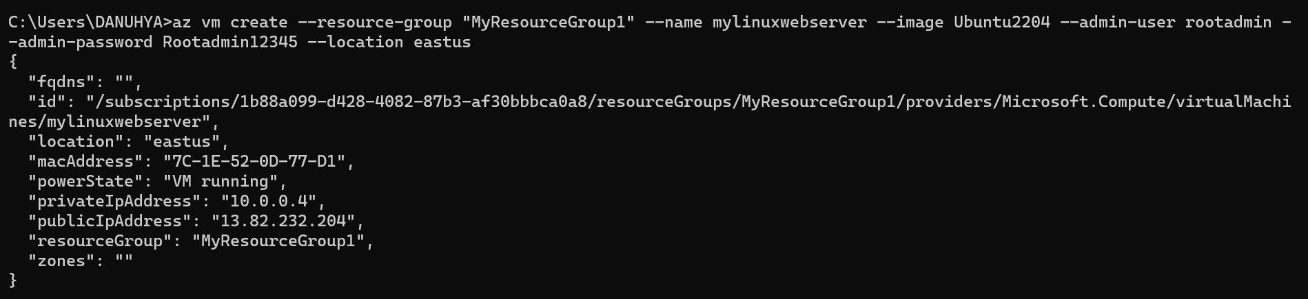

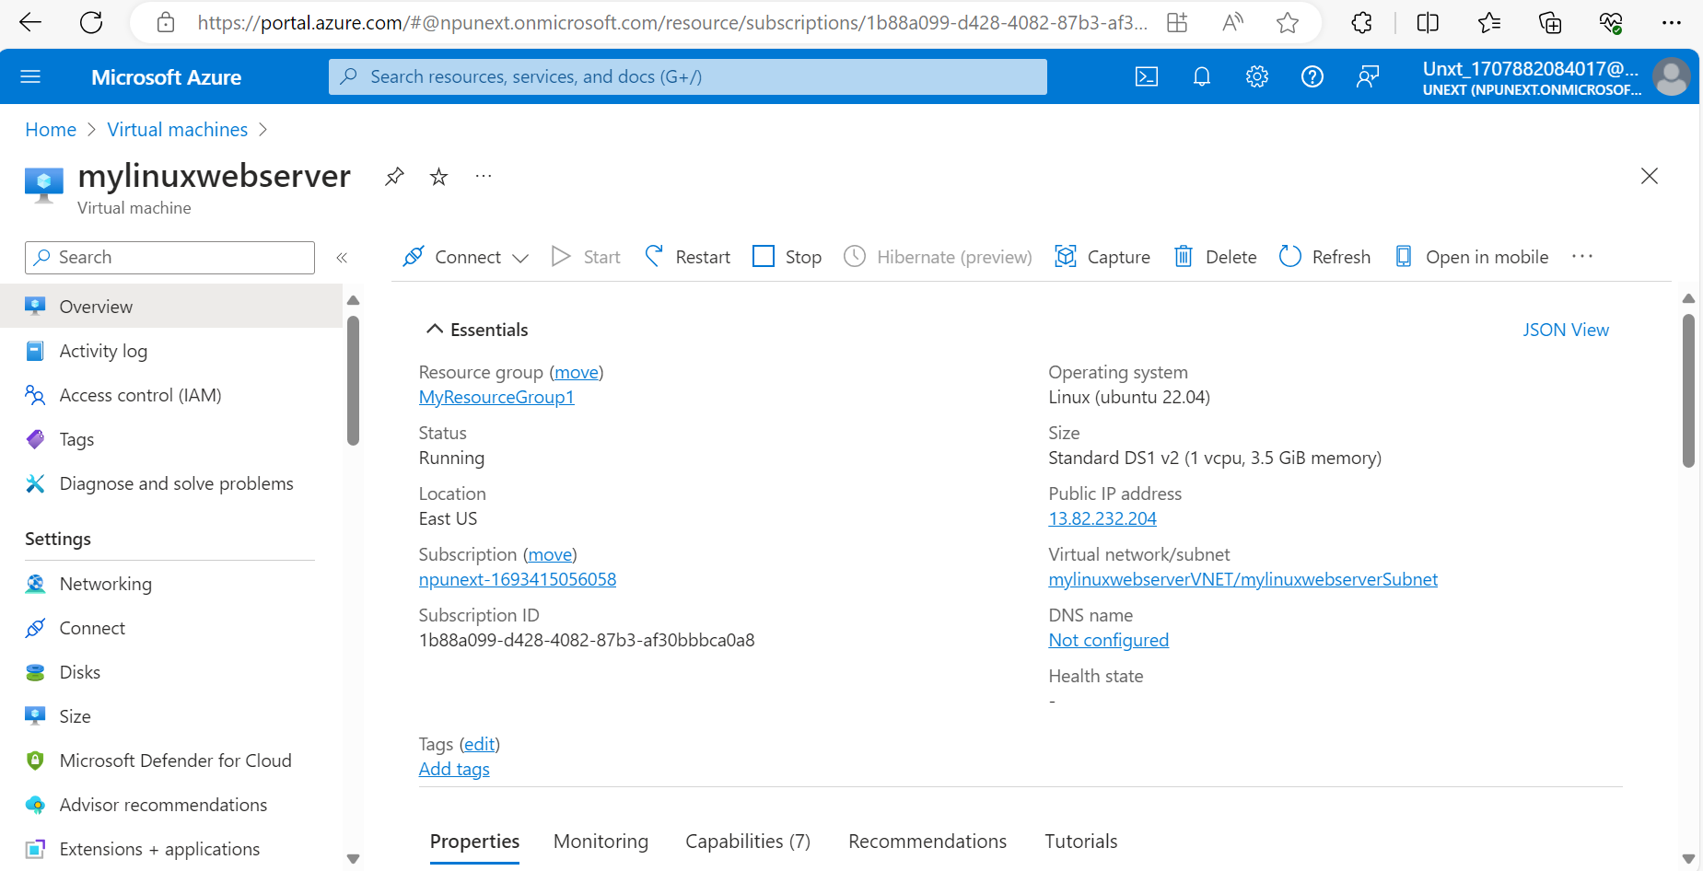

* Access the command line of VM that is created

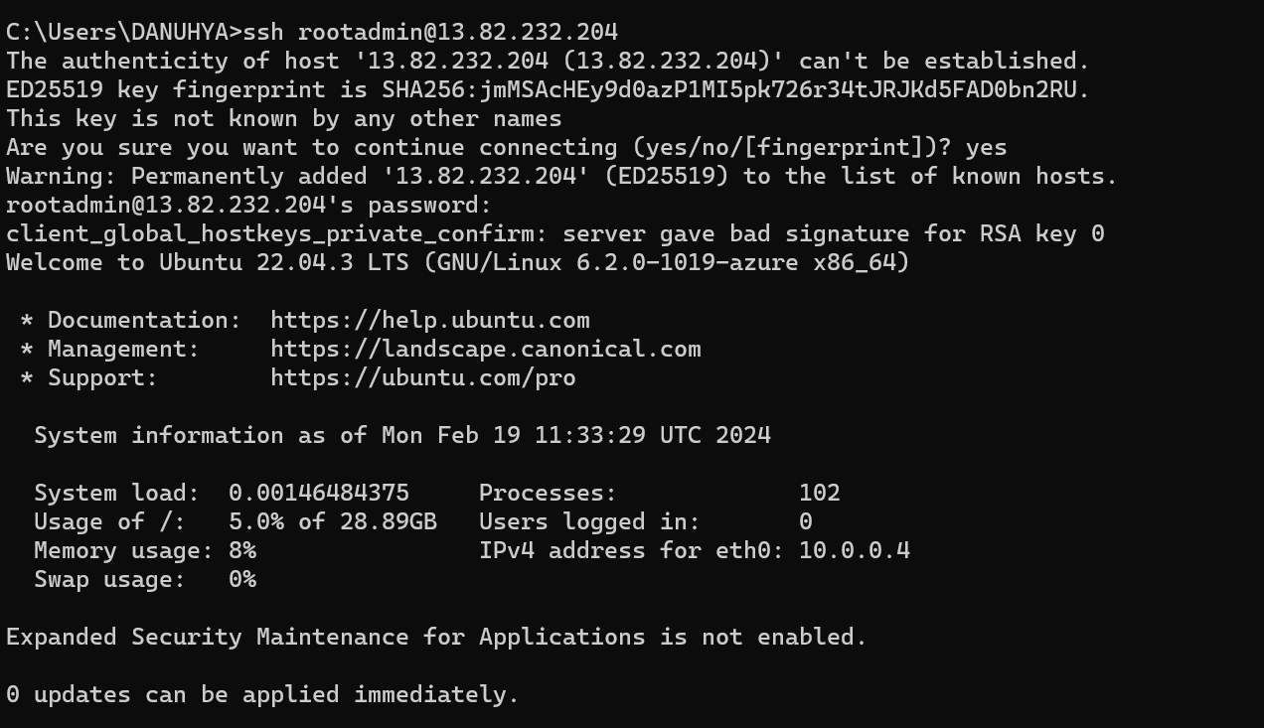

· Update the software so that the latest package is installed in future.

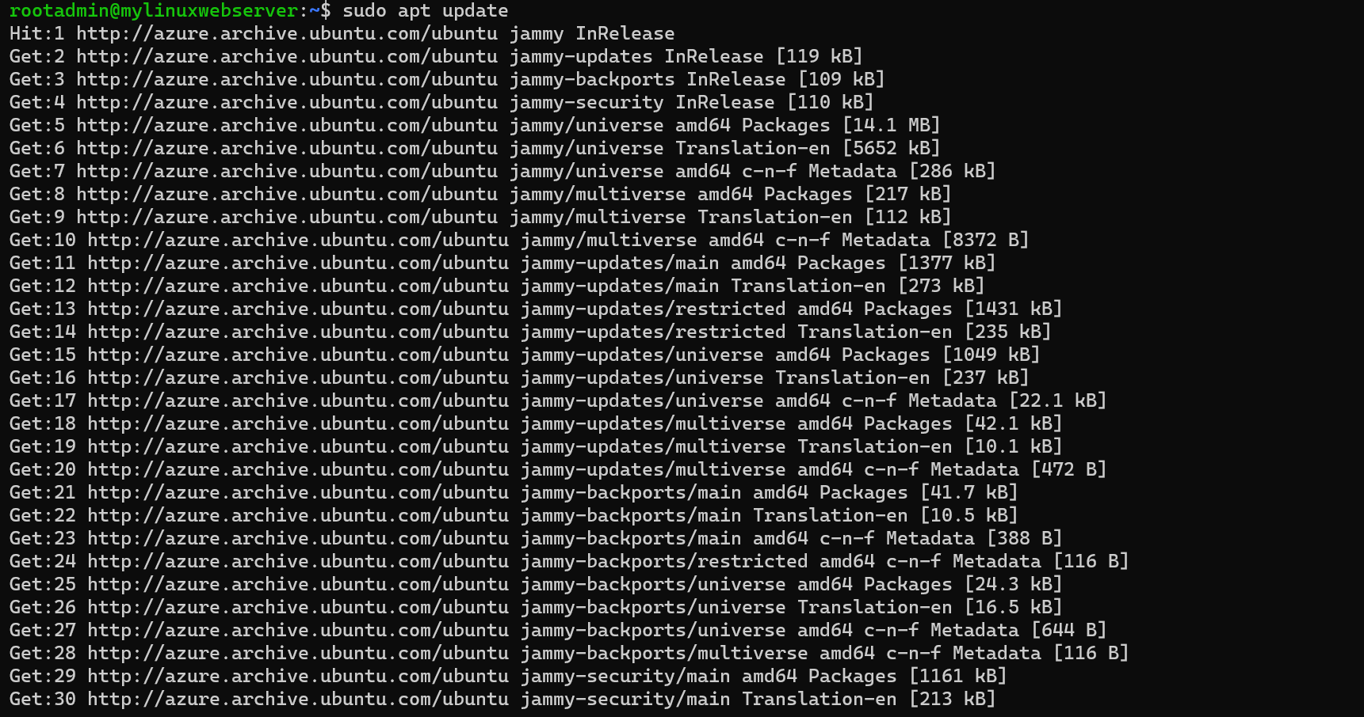

· Install ngnix

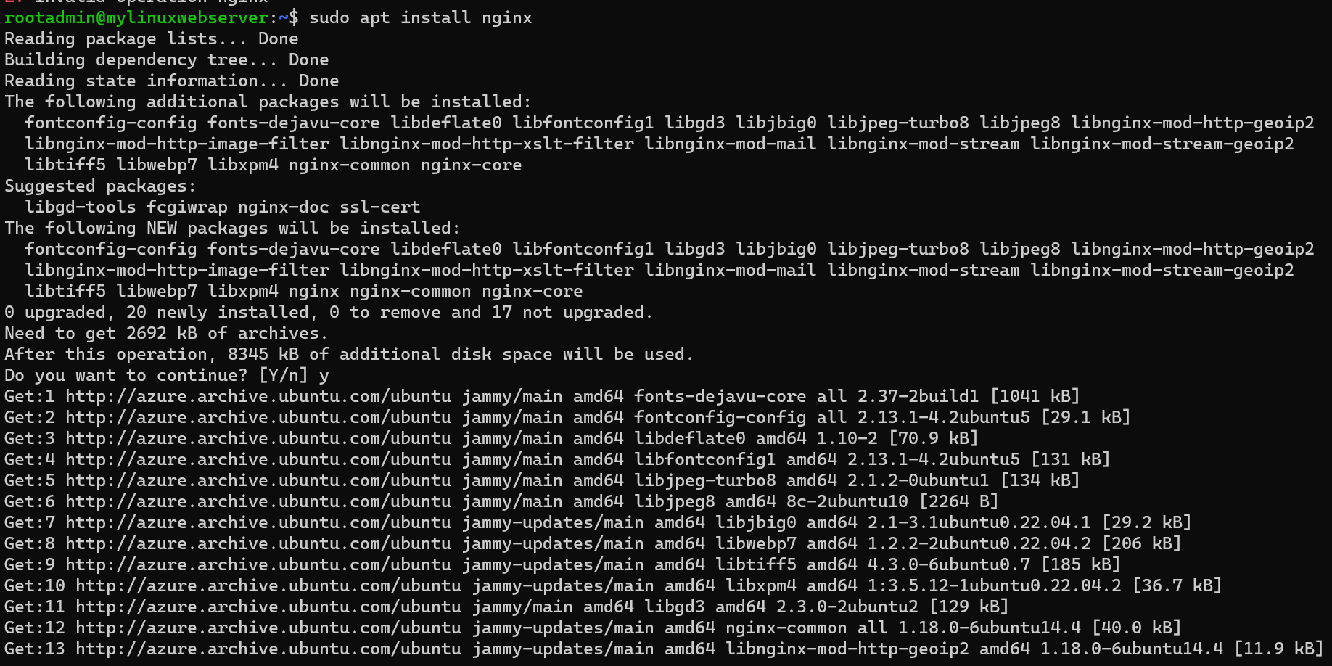

· Verify the default html page is working

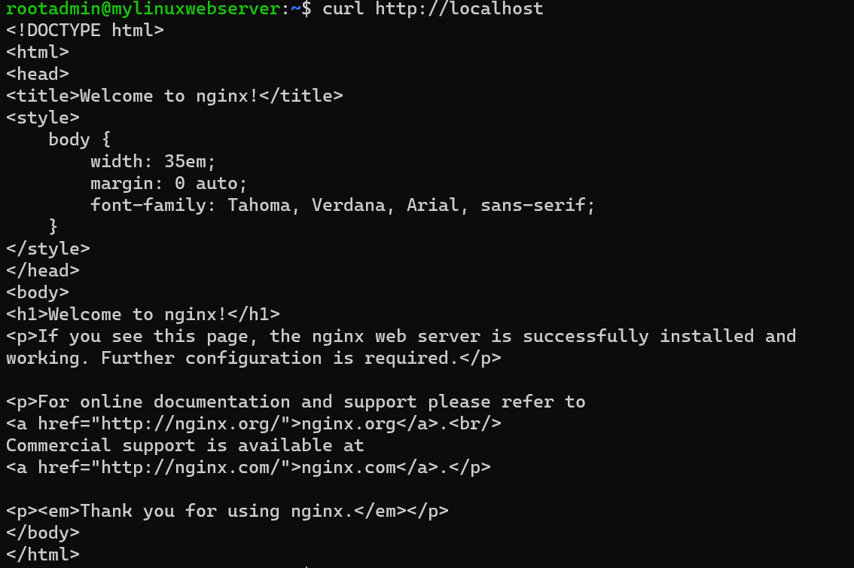

· Add inbound security rule to the MyLinuxServerNSG having priority of 300.

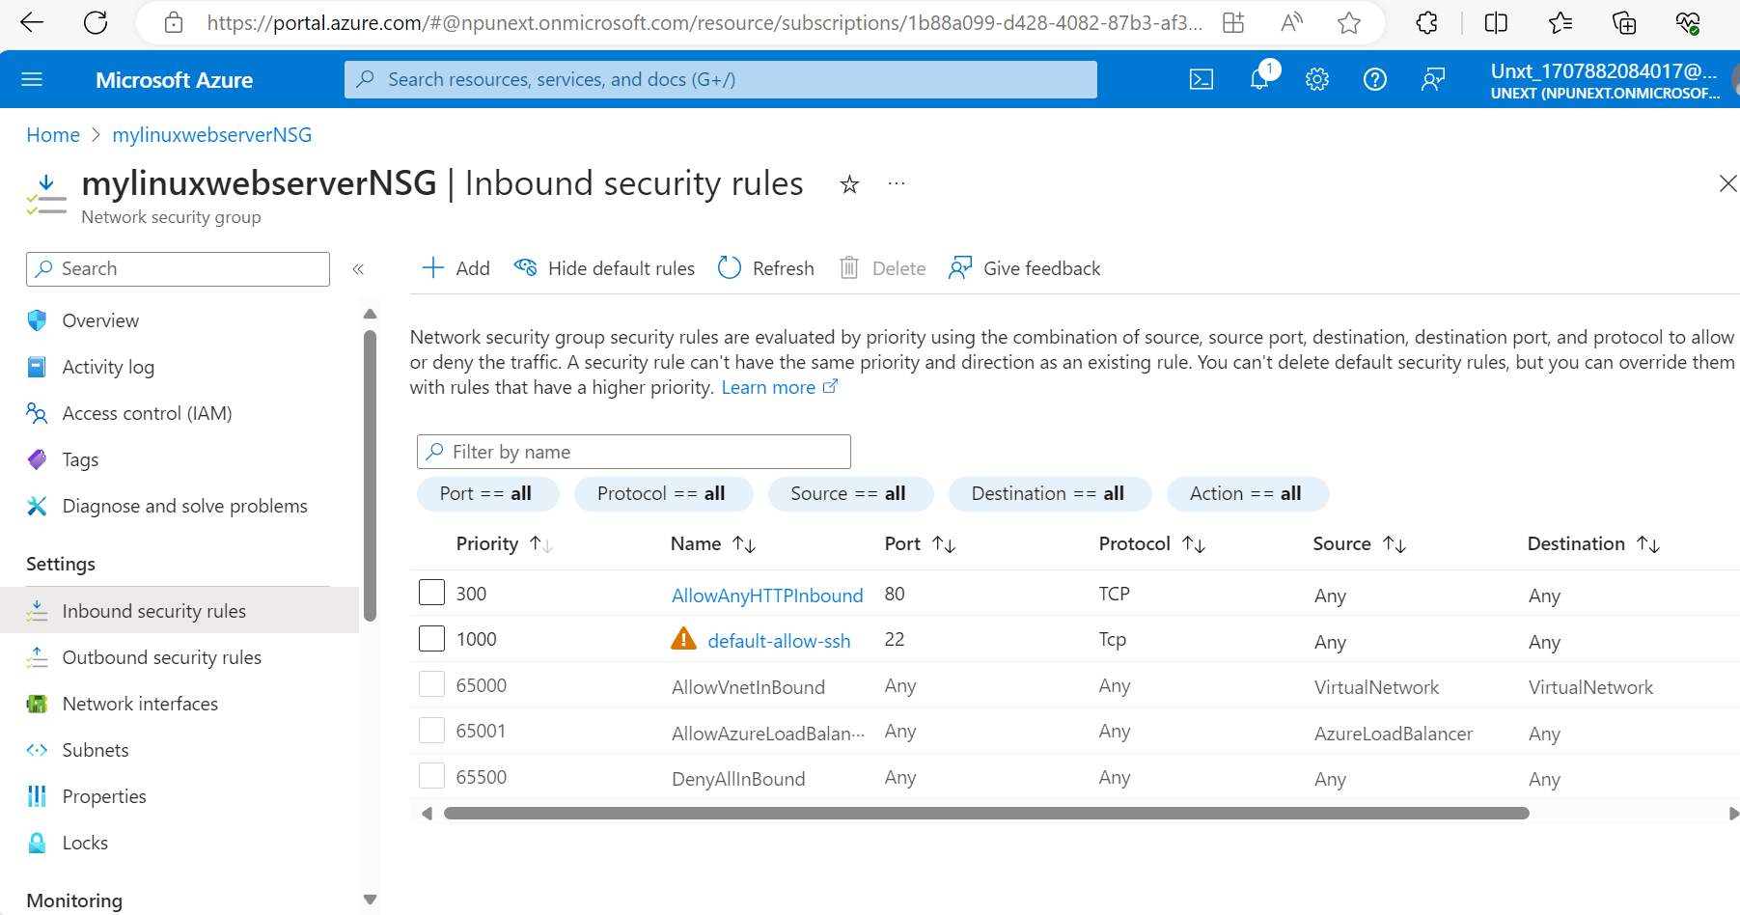

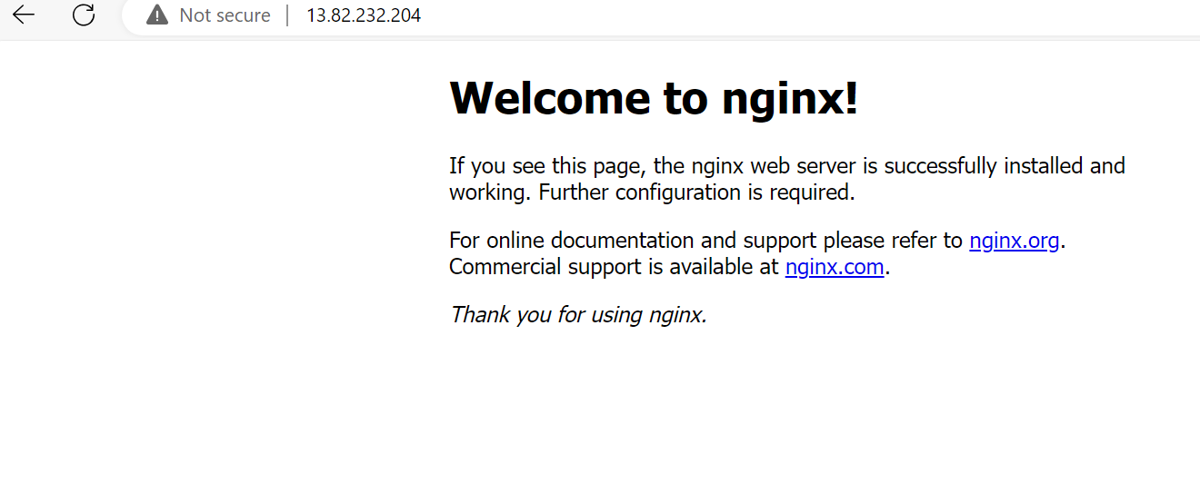

· Give access to read ,write and execute to the files to html and css files in the VM.



· Creating a html, css project on your local machine that need to be hosted on the newly created VM.



